A60-AM,S-Colombia-Tairona-Gold Figurine-Shaman-1000-1500 CE

 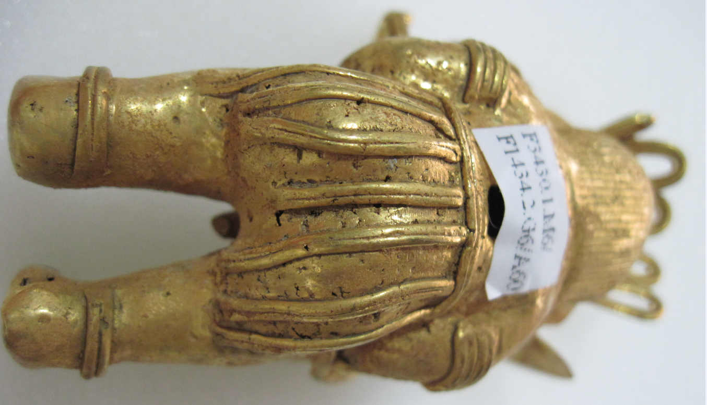

Figs. 1-5

**Case No.: 7**

**Formal Label:** Colombia-Tairona-Gold Figurine-Shaman-1000-1500 CE

**Display Description:** Colombia-Tairona-Gold Figurine-Shaman-1000-1500 CE

This gold figurine is of a *shaman* of the prehistoric (1000-1500 AD/CE) Tairona culture of the Sierra Nevada de Santa Marta**, Colombia**. By 1000 AD/CE Tairona goldsmiths, using the lost wax method, had attained one of the highest levels of technical and artistic achievement in gold-working the Americas. This figurine portrays a ceremonially dressed *shaman* with a feathered headdress, large round earrings, a necklace, arm, wrist and foot bands and a breechcloth probably woven of the fiber of the fique plant, *Furcraea andina*. The *shaman* is holding a mythical serpent in the form of a python (identified by the shape of its head). In the lakes lying at the foothills of the Sierra de Santa Marta such as Guatavita and Iguaque, mythical serpents, which otherwise might be portentious or nightmarish, is held without fear demonstrating that the shaman holding it (with closed eyes to envisage the dream, has attained *aluna*, the Tairona spiritual principle of being in harmony with the cosmos: “each being, even a small stone and the air, maintain the balance of the universe” (See Reichel-Dolmatoff 1988: 68-69).

**Accession Number:** A60

**LC Classification:**  F1434.2

**Date or Time Horizon:** 1000-1500 CE

**Geographical Area:** Sierra Nevada de Santa Marta**, Colombia. Indigenous names are:** Kankuamo (*Umunukunu);* Kogi (*Gonawindua).*

**Accession Number:** A62

**LC Classification:**  F1434.2

**Date or Time Horizon:** 1000-1500 CE

**Geographical Area:** Sierra Nevada de Santa Marta**, Colombia. Indigenous names are:** Kankuamo (*Umunukunu);* Kogi (*Gonawindua).*

**Map, GPS Coordinates:**



Fig. 6. Map of Spanish Provinces in 1600. After <https://html2-f.scribdassets.com/5nmwqq7itc4aqx2e/images/6-a5a093175f.jpg>. Yellow place-holders mark the social “centroids” of k-means clustering algorithms of the four Tairona cultures (in bold) as of 2017 (see Rajput et al. 2012).

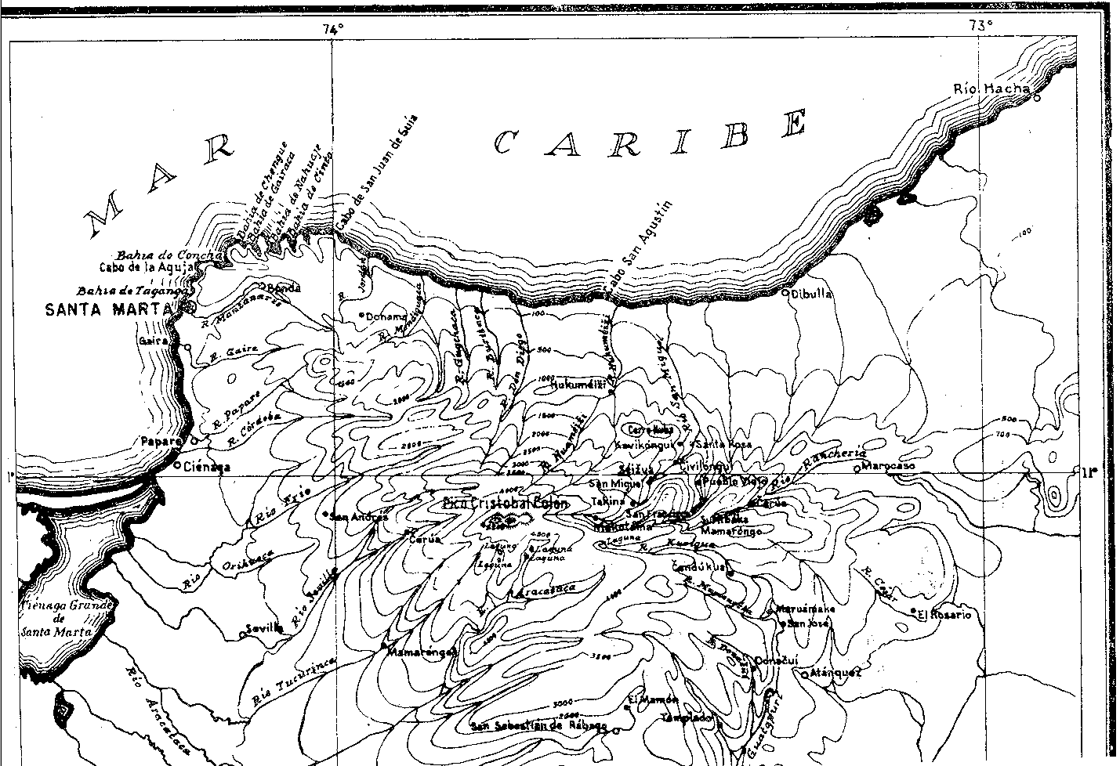

Fig. 7. Topographic map of the Sierra Nevada of NE Colombia. From Reichel-Dolmatoff 1950.

**Cultural Affiliation:** Tairona, Chibcha Language

**Medium:** Lost-wax cast of tumbaga, an alloy of gold and copper. Its surface was subsequently enriched by the depletion method, also known as *mise-en-couleur*.

**Dimensions:** H 104.07 mm, 4.1 in

**Weight: 102 gm; 3.5 oz.**

**Condition: original**

**Provenance:** Tairona villages

**Discussion:**

In addition, spiritual training of the shamans, who are also priests (Mámas) of the Kogi, involves an extremely rigorous preparation that Gerardo Reichel-Dolmatoff has studied first-hand:

All training is carried out under conditions of strictly scheduled lighting changes: for years the novice must live in an enclosure where he must rise at sunset and go to sleep at dawn. The apprentice must lead an entirely nocturnal life; during the night they may go for a short walk and bathe in the river but when there is a moon they should cover their heads with a small woven mat. Besides, the whole training period is accompanied by a complete change in diet. The manifest intention of the priestly teachers is to deflect the child-novices from their accustomed circadian activity rhythms, and to ungear or “declutch” their time perception. It is significant that Kogi priests declare that in children whose training began after the age of five, their circadian rhythms may be very persistent and that, for this reason, they prefer children of two or three years for initial training. (Reichel-Dolmatoff 1990: 6-7).

Since Kogi priests believe that timing can be manipulated, they also believe that light/darkness stimulation can be manipulated for specific ends, and that this can be done quite independently of time. The idea of ‘throwing time out of gear’ - if I may say so - is found mainly in the early stages of priestly training and, later on, in the preparation for mystical experiences. In order to suggest some approaches to the study of the personality of the Kogi priest, we must return to the earliest phases of the training period. The knowledge and interpretation of circadian rhythms is used by the mámas in their attempt to deflect young children from biologically-based activity patterns, in order to create in them another, culturally-defined, perception of the relativity of time and space. Time and space are not thought to set inescapable barriers to the human condition, and a true mama must be able to step outside of time. This endeavour, and the practises it involves, constitute, to say the least, an extremely interesting proposition. The predominantly nocturnal life of the novices is most likely to cause what is known technically as winter depression. In the case of an extraordinarily long period of reclusion this would probably lead to depressive states of a high order. This manipulation of circadian rhythms is combined, in the Kogi case, with a specific, protein-low diet, salt-starvation, severe sexual repression, the absence of female affectivity, unaccustomed iterative learning, the occasional use of hallucinogenic substances, and other practices the nature of which is still little known. In view of these multiple factors in priestly training among the Kogi, even an approximate description of a mama’s personality, would fall outside the limited possibilities of ethnological analysis. (Reichel-Dolmatoff 1990: 9-10).

Although the Tairona were fierce warriors and were able to oppose even the Spanish conquistadores when challenged to submit to an opposing force of arms, the abundance of clearly demarcated flagstone paved paths leading to and from all areas of Tairona settlements indicates that “connection” (trade and exchange) was a more important social value than “exclusion” (confrontation and war), which was seen as only a last resort. Furthermore, in the open, permeable villages of the Tairona, everyone regardless of social status was equally on display with their gold bodily adornments, feather ornaments, bead necklaces, and finely woven cotton apparel (Reichel-Dolmatoff 1951). Moreover, the absence of walls separating élites from commoners allowed daily interaction between peoples of differing status, which was probably mediated by social cues and rules regulating eye contact, bodily gestures, and entrance into ceremonial areas.

The Tairona were so adept at preserving the sanctity of their ancient settlements from vandalism that only in 1965 did Colombian archaeologists uncover a previously unrecorded mountain trail of 1,200 steps in the rain forest on the slopes of Sierra Nevada de Santa Marta, which led to an ancient abandoned city (“Ciudad Perdida”; 11°02'22.9"N 73°55'33.8"W) where gold figurines and ceramic urns were later unearthed. Tairona descendants—the Arhuaco and the Kogi—re-called the site which they called “Teyuna” with its series of 169 terraces and several small circular plazas. Within Teyuna the open, permeable system of unstructured staircases allowed all to participate in a visual and social equality in which the display of gold appurtenances and valued feather headdresses denoted symbols of potential social productiveness accessible to all members of Tairona society. This “open society” can be appreciated in the plot plan and side views of Teyuna’s main cluster of houses (see Fig. 8). Teyuna’s configuration emerged relatively late in the building sequence (ca 11-12th century AD/CE), following an incremental pattern as new areas were added to pre-existing ones by paved paths and staircases that allowed access to any compound from multiple directions thereby ensuring a continuous flow of people to and from any part of the village. Rectangular ceremonial structures excavated by John Alden Mason in 1921/1922 (Fig. 8, no. 52; Mason 1931, 1936) unearthed numerous fragments of double spouted ceramic urns for brewing corn beer, *chichi*.



Fig. 8. Double-spouted *chichi* vessel restored, after Mason 1931, plate CLXXI. Illustrating Great Mother Creator, Gaulcováng and Her children -- Lords of the Cosmos, Seokúkui and Seizankwa.

Artifacts inside these buildings and nearby residences suggest that these locations served as distributed repositories of valued ceremonial goods, such as stone batons and monolithic axes (as symbols of authority and power), winged pendants (used as tinklers suspended from the arms in dances), and beads (carnelian, jadeite, quartz).





Fig. 9. North End of Ciudad Perdida's Central sector (plot plan and side view) showing the rectangular ceremonial center (no. 52) and the overlaps of sequential construction with the altitudinal distances between terraces and subsidiary staircases connected to the main staircase. From drawings by Peter Kellett and Angela Uribe Kellett, 1984 (. Today, however, many Kogi and Arhuaco villages have walls the exclude non-Tairona peoples from entering (see Fig. 9).



Fig. 10. Sign posted on the entryway to an Arhuaco village stating “The entry of non-indigenous people is prohibited …”. From http://assets.survivalinternational.org/pictures/2021/img-2313_screen.jpg.

**Kogi**

Kogi philosophy is based on *aluna*, cosmic harmony. The Great Mother Creator, Gaulcováng (from gau – “to create”), has many manifestations, such as ***Hába Guxsénse***, “Mother of the Eternal Fire,” and Málkwa-yang, “Mother of the Knowledge of Weaving.” Her children -- Lords of the Cosmos, Seokúkui and Seizankwa -- carry Gaulcováng’s Cosmic Egg balanced between two poles between them on their shoulders. When the Cosmic Egg shifts in balance between them, metaphorical earthquakes can result. The metaphysical may have physical consequences, so that right relations with one’s neighbors and the Earth is essential to maintaining cosmic balance.

The Kogi Cosmic Egg is composed of nine worlds that correspond to the nine months of human gestation (Tairona 2015).



Fig. 11. Structure of the Kogi Cosmic Egg. Based on Reichel-Dolmatoff 1978, from Tairona 2015.

**Arhuaco**

Arhuacos’ philosophy is based on Kunsamü -- a sacred, pre-existent, Universal Law that aims to preserve equilibrium and harmony among all beings and is represented by a child, the Máma Niankua. This Law gives rise to the creation of matter and its evolution, balance, preservation and harmony, which constitute the fundamental objectives and the raison d'être of the Mámas (priests), the spiritual authorities of Arhuaco society.

Each Arhuaco Máma is selected from candidates eight to ten years old and each receives an education that lasts at least 9 to 15 years. Extended study allows specialization as philosophers, priests, doctors and practical advisers for individuals and communities. Their influence is decisive in the life of each person and in society.

The main myth of the Arhuaco relates how the Father-Creator Kakü Serankua, in the beginning, created the Chundúa, the highest snow-covered peak (which the Spanish named the “peak of Christopher Columbus,” “Pico de Cristobal Colon,” to de-sacralize it). The Spanish also named the central massif “Sierra Nevada de Santa Marta” but its Arhuaco name is Umunukunu in the Iku language, the “Heart of the World”. Kakü Serankua also created the first gods, and the first men -- the Elder Brothers – the Taironas -- and bestowed upon them the duty of protecting the Earth. Water is greatly revered by indigenous people, and there is enormous opposition to hydroelectric projects in the region, both existing and planned. Dams interfere with the natural cycle of the Sierra's water and threaten the crops and cattle of the indigenous people. Private ownership of land and "development" projects make it increasingly difficult for indigenous people to move through their ancestral territory and make offerings to maintain the planet's balance. Umunukunu has an anthropomorphic being, with the highest peak, Chundúa, corresponding to its head, the lagoons and lakes below to its heart, the rivers and streams to its veins, the layers of soil to its muscles, and the scrublands to its hair.

The Arhuaco community is divided into five divisions:

|  |  |
| --- | --- |
| Central zone | Nabusimake capital of the Arhuacos yechikin and Busín |
| Western Zone | Serankua, Windiwameina and Singuenei |
| South Zone | Zigta, Yeurwua, Gumuke, Yeiwin, Seiarukwingumu, Buyuaguenka and Simonorwua |
| Eastern South Zone | Wirwua, Yugaka and Karwua |
| Eastern zone | Sogrome, Donachwi,  Timaka, Aruamake, Seinimin and Izrwua |

Arhuacos’ main economic sources are coffee, family based agriculture and the manufacture of mochilas or woven cotton bags. In the high plains they grow potatoes, onions, garlic, beans, cabbage, lettuce, blackberry, tree tomatoes, squash, wheat and vegetables. In the middle lands they grow maize, beans, cassava, arracacha, malanga, coca, cotton, pineapple, papaya, guava, passion fruit, passion fruit, orange, and lemon. They also raise chickens, cattle, sheep and goats on a small scale.

Combining the spirituality of the Kogi and the Arhuaco we can see that a duality is implied by their common ancestor, the Tairona, in which there was both a Mother Creator and a Father Creator. Duality of imagery may be seen in many of the gold artifacts of the Tairona suggesting a complex interweaving of complimentary ideas and visual themes.

**References**

Acosta, Joaquin. 1848. *Compendio histórico del descubrimiento y colonización de la Nueva Granada en el siglo décimo sexto.*Paris: Imprenta de Beau.

Adelaar, Willem F. H. and Pieter Muysken. 2004. [*The Languages of the Andes*](https://books.google.com/books?id=UiwaUY6KsY8C&pg=PA75). Cambridge: [Cambridge University Press](https://en.wikipedia.org/wiki/Cambridge_University_Press).

Bischof, Henning. 1982-1983. “Indígenas y españoles en la Sierra Nevada de Santa Marta, siglo XVI,” *Revista Colombiana de Antropología*, 24: 75-124.

Bray, W. 2003. “Gold, Stone, and Ideology: Symbols of Power in the Tairona Tradition of Northern Colombia, in: Quilter J., J. W. Hoopes (eds.), *Gold and Power in Ancient Costa Rica, Panama, and Colombia*. (Washington: Dumbarton Oaks Pre-Columbian Conference Proceedings), pp. 301- 344.

Cardoso P.1987. “Uso y significado de las cuentas tairona,” *Boletín del Museo del Oro*, 19: 117-123.

Coleridge, Samuel Taylor. 1950. *The philosophical lectures hitherto unpublished*. Ed. K. Coburn. London: Routledge and Kegan Paul.

D'Anghiera, Peter Martyr. 1555. *De Orbo Novo*. Trans. Richard Eden as *The decades of the newe worlde or west India conteynyng the nauigations and conquestes of the Spanyardes with the particular description of the moste ryche and large landes and Ilands lately founde in the west Ocean perteynyng to the inheritaunce of the kinges of Spayne*, Book III, §3. London: William Powell.

[EÑES](https://translate.googleusercontent.com/translate_c?depth=1&hl=en&prev=search&rurl=translate.google.com&sl=es&sp=nmt4&u=https://medium.com/somos-enes%3Fsource%3Dfooter_card&usg=ALkJrhhV4slgnlp8CrzVzf2wyo-CDNCwag). 2017. *La Biblioteca como protectora del mundo*. https://about.me/souldes.

Ereira, Alan. 1993. [The Elder Brothers](http://www.amazon.com/Elder-Brothers-Alan-Ereira/dp/0679743367/ref=tmm_pap_swatch_0?_encoding=UTF8&sr=&qid=). New York: Vintage Books.

Falchetti A.M. 1987. “Desarrollo de la orfebrería Tairona en la provincia metalúrgica del norte

Colombiano,” *Boletín del Museo del Oro*, 19: 3-23.

Fabré, Alain. 2005. [*Diccionario etnolingüístico*](http://www.ling.fi/Entradas%20diccionario/Dic=Chibcha.pdf) y guía bibliográfica de los pueblos indígenas sudamericanos. Internet Electronic File.

Frank, Paul S. 1992. “Reconstrucción de las variaciones en Proto-Aruaco,” *Thesaurus (*Bogotá)47: 532-542.

1993. “Proto-Arhuacan phonology,” *Estudios de Lingüística Chibcha,* 12: 95-117.

Gutierrez Hinojosa, Tomas Dario. 2000. Valledupar Musica de una Historia. Bogota: Editorial Grijalbo LTDA.

Hammarström, Harald; Forkel, Robert; Haspelmath, Martin; Bank, Sebastian, eds. 2016. [*"Kankuamo"*](http://glottolog.org/resource/languoid/id/kank1244). [*Glottolog 2.7*](https://en.wikipedia.org/wiki/Glottolog). Jena: Max Planck Institute for the Science of Human History.

Joshua Project, 2017: <https://joshuaproject.net/people_groups/13448/CO>

Legast, A. 1982. “La fauna mítica Tairona,” *Boletín del Museo del Oro*, 13:1-18

Legast, A. and A. Cadena. 1986. “El murcielago en el material arqueologico, colombiano,” *Boletín de arqueología*, 1(3): 25-34.

Mason, J.A. 1931. *Archaeology of Santa Marta. The Tairona Culture.* Part 1. Anthropological Series, 20(1). Chicago

1936. *Archaeology of Santa Marta. The Tairona Culture.* Part 2. Section 1. Anthropological Series, 20(2): 1.

National Institutes of Health; Committee to Review the Health Effects in Vietnam Veterans of Exposure to Herbicides. 1994. [*Veterans and Agent Orange: Health Effects of Herbicides Used in Vietnam*](https://books.google.com/books?id=2YQTHJlt5l4C&pg=PA90). Washington: National Academies Press.

Oyuela-Caycedo, A. 1986. “De los Tairona a los Kogi: Una interpretación del Cambio Cultural,” *Boletín del Museo del Oro*, 17: 32-43

2005. “El surgimiento de la rutinización religiosa: los orígenes de los tairona-kogis.” In Chaumeil J.P., R.P. Camacho and J.F. Bouchard (eds.), *Chamanismo y sacrificio, Persectivas arqueológicas en sociedades indígenas de América del  Sud*. Bogotá, pp. 141-163

2010. “The Forest as a Fragmented Archaeological Artifact.” In Dean R.M. (ed.), *The Archaeology of Anthropogenic Environments*. Carbondale: University of Michigan Press, pp.75-94.

Panoramas. 2015. <http://www.viewfinderpanoramas.org/panoramas.html#longlines>

González-Plazas, Santiago. 2008. *Pasado y presente del contraband en La Guajira aproximaciones al fenómeno de ilegalidad en la region.* Bogotá: Centro de Estudios y Observatorio de Drogas y Delito Facultad de Economía, Universidad del Rosario.

Plazas, C. 1987. “Forma y fución en el oro Tairona,” *Boletín del Museo del Oro*, 19: 25-33.

Rajput, D. S., R. S. and G. S. Thakur, and Neeraj Sahu. 2012. “Analysis of Social Networking Sites

Using K- Mean Clustering Algorithm, *International Journal of Computer & Communication Technology*, 3: 88-92.

Réclus, Élisée. 1875-94. La Nouvelle Géographie universelle, la terre et les hommes, 19 vol. Paris.

Reichel-Dalmatoff, Gerardo.1942. "Apuntes arqueológicos de Soacha," *Revista del Instituto Etnológico Naccional*, pp. 15-25.

1953a. “Contactos y cambios culturales en la Sierra Nevada de Santa Marta,” *Revista Colombiana de Antropología* 1(1): 15-122.

1953b. “Investigaciones arqueológicas en el departamento del Magdalena: 1946-1950. Parte III: arqueología del bajo Magdalena.” *Divulgaciones Etnológicas* 4(4): 1-96 + 23 láminas. Barranquilla: Instituto Etnológico del Atlántico.

1954a. “Investigaciones Arqueológicas en la Sierra Nevada de Santa Marta. Partes 1-2,” *Revista Colombiana de Antropología,* 2(2): 147-206.

1954b. “Investigaciones Arqueológicas en la Sierra Nevada de Santa Marta. Parte 3,” *Revista Colombiana de Antropología,* 3(3): 141-170.  
  
1959. “La Mesa. Un complejo arqueológico de la Sierra Nevada de Santa Marta,” *Revista Colombiana de Antropología,* 8: 159-214.

1963. “Investigaciones arqueológicas en la Costa Pacífica de Colombia II- Una secuencia cultural del Bajo Río San Juan,” *Revista Colombiana de Antropología,* 2: 9-81.

1990. “The Sacred Mountain of Colombia’s Kogi Indians,” *Iconography of Religions*, sec. 9, South America, fasc.2, Serie M. Leiden.

1997. *Arqueología de Colombia: Un texto introductorio* (1986)*.* Bogotá: Imprenta Nacional de Colombia.

Reichel-Dalmatoff, Gerardo and Alicia Dussan de Reichel. 1942. "Las urnas funerarias en la cuenca del río Magdalena", *Revista del Instituto Etnológico Nacional*, Bogotá, pp. 109-160.

1951. “Investigaciones arqueológicas en el departamento del Magdalena: 1946-1950”. Parte I: “Arqueología del río Ranchería; Parte II: “Arqueología del río Cesar”. *Boletín de Arqueología,* III(1-6): 1-334. Bogotá: Instituto Etnológico Nacional.

1955. “Investigaciones arqueológicas en la Sierra Nevada de Santa Marta. Parte IV: sitios de habitación del período Tairona II, en Pueblito,” *Revista Colombiana de Antropología,* 4: 189-245.

1961. "Investigaciones arqueológicas en la costa Pacífica de Colombia :I - El sitio de Cupica" *Revista colombiana de antropología,* Bogotá. 10: 237-317.

1987. “Arquitectura y Urbanismo en la Cultura Tairona,” *Boletín del Museo del Oro,* 19: 87-96.

Romero, Francisco. 1955. [*Llanto sagrado de la América meridional ... Lo publica nuevamente, conforme a la edición milanesa de 1693, con una introducción biográfico-crítica, Gabriel Giraldo Jaramillo.* [With a title-page facsimile.]](http://explore.bl.uk/primo_library/libweb/action/display.do?tabs=moreTab&ct=display&fn=search&doc=BLL01003152660&indx=2&recIds=BLL01003152660&recIdxs=1&elementId=1&renderMode=poppedOut&displayMode=full&frbrVersion=2&frbg=&&vl%28488279563UI0%29=any&dscnt=0&scp.scps=scope%3A%28BLCONTENT%29&tb=t&vid=BLVU1&mode=Basic&srt=rank&tab=local_tab&dum=true&vl%28freeText0%29=%20%09Francisco%20ROMERO%2C%20Augustinian&dstmp=1503759632526) Bogotá

1693. *Llanto sagrado de la America Meridional, que busca alivio en los Reales ojos de ... Don Carlos segundo, Rey de las Españas ..., para mayor incremento de la militante Yglesia, restablecimiento de la monarquia, y nueva dilatacion del Imperio Indiano*. Milan.

Sievers, Wilhelm. 1986. “Die Arhuaco-Indianer in der Sierra Nevada de Santa Marta,” Zeitschrift der Gesellschaft fuer Erdkunde, 21: 388-400.

SIL International *et al*. 2005. *Ethnologue: Languages of the World*. Dallas, Texas: SIL International.

Tairona. 2015. <http://tairona.myzen.co.uk/>).

Vinalesa, José de. 1952. *Los indios arhuacos de la Sierra Nevada de Santa Marta*. RIEN. Bogotá: Editorial Iqueima.

**APPENDIX:**

The Four Tairona Ethnolinguistic Sub-groups of the Chibcha Language Family, Kuna Sub-Family, Arhuacicio Group:

**Arhuaco (aka Aruaco, Bintuk, Bintukua, Binmticua, Ica, Ijka, Ika, Ike), pop. 14,301, (Arango and Sanchez 1998, SIL 2005); S slope,** 10°42'N, 73°38'W.

**Kankuamo (aka** Atanque, Atanques, Cancuamo, Kankwe, Kankuí, Kankuaka, Kankuané)**, pop. 15,000 (**<https://en.wikipedia.org/wiki/Kankuamo>**;**Hammarström, Forkel, Haspelmath, Bank, 2016)**; S slope,** 10°45'N, 73°21'W

**Kogi** (aka Cogui or Kágaba, Kággaba = “jaguar”), pop. 9,770 (SIL 2005, 1998 census); N, E, W slopes; 10°57'N, 73°48'W.  
**Malayo (aka** Arosario, **Arsaro,** Damana, Guamaca, Gauarmaka, Guamaco, Maracasero, Sanja, Sanka, Wiwa) (**SIL 2005,** Hammarström, Forkel, Haspelmath, Bank 2016; pop. 7,000, Joshua Project 2017**): S, E slopes;** 10°56'N, 73°24'W.

**ARHUACO**

The Arhuacos live in the upper valleys of the Piedras River, San Sebastian River, Chichicua River, Ariguani River, and Guatapuri River, in an indigenous territory of the Sierra Nevada de Santa Marta Mountains. Their traditional territory before the Spanish colonization, was larger than today's boundaries which exclude many of their sacred sites that they continue to visit today, to bring offerings.

A recently discovered seventeenth century document in the Vatican Archives recounts how the Arhuacos had “temples, which in their language they call Sansamarias, … dedicated to the devil and where … they made … sacrifices of carved stones, of clothes, of jewels and of horrible mortifications, like fasting for fifteen days without more than a little grain of corn and other harshness that the devil made them do ... . And … among the detestable idols that they had in their temples, they venerated three principal gods whose names were Cabisurí, Dunama, and Moatama, and that if they wanted to see the little strength of their gods, they would take me to their altars which were carved from large logs and [they would] see how I destroyed them with only a small weapon, and I slashed a cross on their chests … that they should know their deception, seeing that all the strength of their gods did not have the strength to defend themselves … for self-defense ...” (Romero, 1955: 82-3). “There were four or five hundred Indians who came to the Spanish town, where a church had been built by the conquistadors … who with their swords instructed and received them into the guild of Catholicism. As soon as [the conquistadors] saw the crowd of Indians, a heat of covetousness overtook them to make slaves of those who came to be in Jesus Christ, for they were no more of the devil. They came to us amicably, and the conquistadors told them that if they wanted to congregate in the church and see the holy sacrifice of the Lord, they would have to put their bows and arrows outside the temple. They did not hesitate to obey, for what they desired, and the Spaniards recognized this obedience… and with caution, they began to cut the ropes of the archers' arrows brought by the Indians.” In the hunt for Arhuaco sanctuaries the Catholic bishop questioned the Arhuaco cacique [Serveme Guaimazo] “I have been told that you are Idolatrous, adoring the devil for which you have many temples which you call Cansas Marias, and in them they make many harsh fasts, And many sacrifices to the devil that speaks to you by idols, and, as you do not know his deceit, you believe it and so that you know God has brought me here [for you to] show me the sanctuaries that are in various parts of the Sierra, and all the idols that You worship for gods, mainly Canbisurix, Dunama and Moatama, and the others whose names we do not know. If you acceed to our desire and show with sincerity and truth the false gods of your adoration I promise you in the name of God our Lord and Of our Catholic King of Spain to offer you gifts of our choosing and to give you access to everything lawful. But, [should you not submit] otherwise, … you will be stripped of your land and living, and I will take you prisoner and present you to my King and Lord God.” Thus the Arhuacos “were reduced to ‘Living under house arrest,’ many were enslaved, if not massacred, by captains and conquistadors and henchmen, with the connivance of the colonial governors and other officials of the different provinces.”

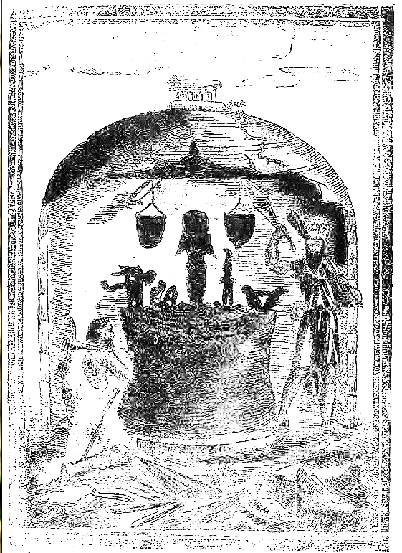 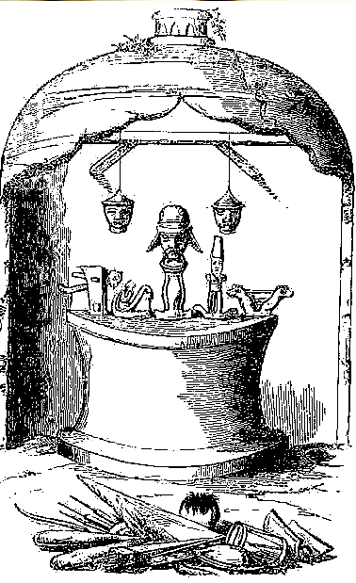

Fig. 12. “The idolary of the Indians of the Arhuacos Nation who live in the Sierra de Santa Marta, destroyed by a religious of the order of Saint Augustin of the Province of Lima and the Law of [16]91 . [This is] one of their temples in which are found the abominable cultic idols to the Devil.” From Romero 1693.

Fig. 13. “Representation of one of the shrines of the Arhuaco Indians in the Sierra Nevada of Santa Marta, destroyed by Father Francisco Romero, of Augustin order.” From Acosta 1848.

Those who offered the best defense against the Spanish conquistadores “were condemned to slavery. Or to the servitude of an oar in the galleys of Cartagena, where some will be found today; … Others were hanged in the city of the King (Santa Marta) and, in the Valley of Upar [in NE Colombia, named for the Arhuaco cacique **Upar]**. Some Indians retreated to the mountains and gave notice of the sacrilegious deceit of the Spaniards to other infidels, … But in an the extraordinary event they withdrew …and angered … all to avenge the injuries of their compatriots; Which they carry out very often today, because they have seized an impenetrable base of insurgence, which is Mount Carupa [3,700 m asl, in N Cundinamarca], where every day they hunt for soldiers, and it is rare that they leave without making cruelty on this prey. This was when I recognized the abundance of dead bodies that I saw in the space of two leagues… . (Romero, 1955: 116-117). Today these territories, so fiercely fought for in the massif, have been lost to colonial farming due to the lack of protection from the Colombian government.

In 1916 the Arhuacos requested teachers from the government to learn to read, write and study arithmetic, but instead the government sent Capuchin monks. The Capuchins had themselves undergone severe training for their missionary work in learning how to shed the taints of polytheism of their charges based on the Inquisition’s lessons. They applied brainwashing rigorousness wholeheartedly to the children and prohibited them from learning about their language and their culture by establishing what was regarded as a “*Régimen de terror.*” They put them in isolated orphanages away from their parents, whom they also placed in forced labor camps, ignoring the Arhuacos’ pleas to be left alone. Twenty years passed until in 1943, Capuchin missionaries and the Ministry of Agriculture, expropriated without compensation the best terrains of Nabusimake and built a state-owned, agricultural farm there. Finally, the Arhuacos fought back again and in 1944 created their own *Liga de Indios de la Serra Nevada* (Sierra Nevada Amerindians League), but this was too successful, and it was outlawed in 1956 by a military government. If this were not enough, another challenge came in 1962, when the government built a TV microwave tower on Mount Alguacil, a sacred Arhuaco mountain. In response to Arhuaco demonstrations the government built a military post on the mountain to intimidate them, and then ordered a highway to be constructed through their farming area to Valledupar. Ignoring these threats, the Arhuacos re-established their *Liga de Indios*, and in 1972 they created the *cabildo Gobernador*, a better-structured organization to defend their land with real lawyers.

Then in 1975 the drug craze hit Colombia. Colonials started cultivating marihuana on Arhuacos’ land and initially imposed conscription on them to work their fields, but as the real marihuana bonanza hit in the late 1970’s, some Tairona were released tp voluntarily work for escalating wages. Simultaneously, commercial coca planting was begun by drug dealers, but this evolved into the Colombian Armed Conflict period where guerrillas and paramilitaries of different drug lords competed for control of the Arhuacos’ land. In response, the government charged the Tairona tribal groups with drug production and many were intimidated and, if not, assassinated, while the real producers went free. This was to show the international audience (especially the US) that the Colombian government was rooting out drug production, whereas, in fact, it was escalating under Presidents Reagan, Bush and Clinton. Furthermore, the government began fumigating Arhuacos’ land with Agent Orange, a defoliant that had been used by the US in the Vietnam War, “Operation Ranch Hand” from 1961-1971, and now the US supplied it to the Colombian government to eradicate illicit coca. This highly toxic spray contains 2,3,7,8-tetrachlorodibenzo-p-dioxin (TCDD) a deadly carcinogen that damages genes, resulting in birth defects, promotes leukemia, Hodgkin's lymphoma, and various cancers (National Institutes of Health 1994: 90). The Arhuacos have been suffering these diseases ever since.

Apart from the drug wars the Colombian government is constructing hydroelectric dams and ecotourism routes into the Sierra Nevada de Santa Marta. The Arhuacos are strongly opposed to both of these projects and have organized the *Confederación Indígena Tairona* (Tairona Indigenous Confederation). The success of this effort has yet to be determined. *Mámas* are duly charged with protecting their spiritual rights as their appointed caciques are appointed to protect their political rights. This golden figurine dating to before the Spanish conquest suggests the equanimity the *Mámas* have in confronting challenges. 

Fig. 9. Six experienced Kogi *Mámas*. From http://ifmanworld.org/wp-content/uploads/2015/10/IMG_0106-2.jpg

**KANKUAMO**

The area inhabited by the Kankuamo (aka Arzario, Chimila, Ette Ennaka, Guanebucanes, Wiwa) in N Colombia was confiscated by the Province of Santa Marta in 1524 (See Map, Fig. 6).Two hundred years later in 1720 the Kankuamo began a guerrilla war against their Spanish colonial overlords. However, the Spanish, continued to colonize the plains surrounding *Gonawindua* (Sierra Nevada de Santa Marta). By 1850 the Spanish were proceeding to colonize the massif itself, but in order to do this they had to remove the indigenous from their mountainous settlements to less valuable land. Under the spiritual guidance of a Kankuamo *Máma*, Tukaka, the indigenous were removed to three new villages -- Atanquez, Maraocaso and El Rosario -- which grew due to the displacement of other people. Even former African slaves were removed to Atanquez, forming the “Palenque of Atanquez.” The Spanish sent Capuchin and Dominican monks to “civilize” these mixed exogenous and indigenous heathen and named it San Sebastian (Gutierrez Hinojosa 2000: 127). Even the indigenous had trouble settling on a name for this settlement: the Kogi named these people the "Wiwa", while the Arhuaco called them "Arzario.” Sporadic violence continued into the mid-twentieth century, until, in 1990, an indigenous reservation called “Issa Oristuna” was created (Adelaar and Muysken 2004: 75).

Between 1986 and 2003 the Colombian Armed Conflict involved the people of Atanquez with 197 Kankuamos executed by the paramilitary gr**oup *Autodefensas Unidas de Colombia*  (AUC, “United Self-Defenders of Colombia”), and two guerrillas** units the *Fuerzas Armadas Revolucionarias de Colombia*  (FARC, “Revolutionary Armed Forces of Colombia”) and the *Ejército de Liberación Nacional* (ELN, “National Liberation Army”). These groups flourished in the region due to the marijuana bonanza of the 1970’s and later the use of their traditional coca plants to produce cocaine and the introduction of opium poppy (*Papaver somniferum*)plantations (González-Plazas 2008), while at the same time they continued in the production of traditional food stuffs such as panela (unrefined whole cane sugar), alcohol from maize and sugar cane, fique (a natural fiber of the fique plant, *Furcraea andina,* used in textiles and ropes), medicinal plants, local fruits and vegetables, cacao and coffee which is commercialize in Valledupar (Gutierrez Hinojosa 2000: 126).

**KOGI**

Kogi cosmology has seven points of reference (North, South, East, West, Zenith, Nadir and Center) and within these points is encompassed the cosmic egg created by the Mother-Goddess, our world being the fifth, or center, of nine horizontal belts which constitute it. ‘The seven points ... are associated ... with innumerable mythical beings, animals, plants, minerals, colors, winds, and many highly abstract concepts’ whilst the four cardinal points ‘are under the control of four mythical culture heroes who are also the ancestors of the four primary segments of Kogi society ... and ... are associated with certain pairs of animals that exemplify the basic marriage rules’. Thus the rules prescribe that a man from the Puma patriline will marry a woman from the Deer matriline and so on, this teaming of natural opposites being another example of how balance is maintained in the society. Dualities, opposed yet complementary, are recognized everywhere. A village is divided by an invisible line, known to all, into two sections, the sun divides the sky into a right and a left side and the ‘nuhue’ is divided by the line between the two entrances into two parts, each with its own central post and each designated either male or female.



Fig. 10. A Kogi village nestled into a tiny valley high in **the** (Sierra Nevada de Santa Marta) **at 10°57'N, 73°48'W; from** <https://laviebyc.files.wordpress.com/2014/10/image39.jpg>**.**

Two center posts in each domicile, male and female, express Kogi duality in architecture (see **Fig. 10)**. The two posts also metaphorically carry the Cosmic Egg as supported on the shoulders of Seokúkui and Seizankwa two spiritual offspring of the Mother Goddess.

Among the Kogi *Mámas* are identified at birth by a process akin to that of the choice of the next Dalai Lama. A dream or sign that is sensed by an elder *Máma* provides the incentive to search for the destined baby.Once identified, the baby is taken from his birth-home at three months to live with the chief *Máma* and his family, in which he is given moral training and instruction in the rituals and traditions of the village. Then when he becomes of age, about twenty, his role as a *Máma* begins, as a confessor to the people that demands his ability to listen empathically and to probe the troubled mind of his confessant or indeed anyone of the village who has need of his advice or counsel. Gerardo Reichel–Dolmatoff who spent eight months with the Kogi in the late 1940’s stated “I know of no case, however, where a *máma* would have taken advantage of this knowledge for his own ends” (Reichel-Dolmatoff 1976: 272). The *Máma* also carries the traditions of the Tairona with him. For instance, the people are taught that death is a tragic event but rather a fulfilment of life and a liberating event, a time when the individual returns once more to the body of the Mother Earth, Gaulcováng. Life is seen as an intermediary, intra-uterine state in which one emerges from the watery life in the womb to experience a period of trials beginning with birth from a fluid environment—to undertake tasks that must be accomplished on earth--and then to return to Gaulcováng (Reichel-Dolmatoff 1976).

Since rocks emerge from the essence of Gaulcováng, the Tairona have an allure of communicating through petroglyphs. Many of these images, which are abraded into stone (usually large boulders) by ancient Mámas are used to encode special images of traditional worship, astronomy, stories, folklore and myths.



Figure 11. Engraved petroglyph at the foot of the great central staircase at “Ciudad Perdida Archaeological Park” may represent the hub and spoke arrangement of settlements and paved paths spread throughout the landscape of the Buritaca River Basin. Its placement at the entry point to the central area may have served as a display of authority of the Kogi polity. From ()Figure 6.1, p. 305.

A boulder covered with petroglyphs suggests the inchoate “Moment of Creation on Earth”. It presents in visual meanders and curvi-linear figures what myths present in words (revised from a Kogi creation myth from Ereira (1993):

In the beginning, blackness.  
Only sea.  
In the beginning -- no sun, no moon, no people.  
In the beginning -- no animals, no plants.  
Only sea.

Sea was Mother. Mother was not people, not any Thing.  
No Thing at all.  
She was -- ominous.  
She was -- potential.  
She was -- *aluna*.



Fig. 11. The Creation Stone of Doanama, with a *Máma* guarding it while presenting its message. <http://intermundos.org/en/wp-content/uploads/2009/01/duanama1.jpg>

The Kogi are also practical about sexual and social relations. Couples are free to divorce and women are free to abort a fetus. Homosexuality and trans-sexuality are accepted.

**MALAYO**

About 7,000 Malayo live in the south and east valleys, between Valledupar and Santa Marta. They have democratic governance in which men meet every month in the men's house and stay all night discussing and voting on all conflicts and ideas led by *Cabildes* (caciques) and *Mámas* (priests). Inhabitants have two houses, one on their farmland where they live most of the time and one in the village where they stay during town meetings, so they take these meetings seriously. Furthermore, they visually express their cultural identity as descendants of the Tairona by always wearing white cotton clothes and long hair. Since only about 65% of the Malayo speak their native language of *Damana*, and this may contribute to differing demographic figures as various *Damana* words are used to refer to households within the settlements (Joshua Project 2015). “The Malayo are very poor. Malnutrition is a major problem among the children and medical care is usually at least a day's walk away. The child mortality rate is high. Settlers are encroaching on their land, and many have already been displaced because of violence. Education is very sparse and of poor quality. One of the reasons for this is that there is still no set alphabet to write their language (*Damana*). They have no part of Bible translated into their language as of yet and no missionary is currently working in their land” (Joshua Project 2015).





Fig. 11. A Kogi *Máma* chanting to the Cosmos with two striking sticks in front of an ancient Men’s House that has fallen into ruins. He is dressed in traditional white cotton, signifying purity, with his essential snake boots to preserve the harmony with nature! In the background is an ancient dwelling on the hillside, its excavated outline is the only thing visible. http://ifmanworld.org/wp-content/uploads/2016/03/00160.jpg



Fig. 12. Tairona house platforms at Teyuna village called “Ciudad Perdida” ca. 100 BCE that terraced the steep mountainsides for circular structures, both domestic and ceremonial. From <http://lostcitytrekcolombia.com/wp-content/uploads/2014/09/lost-city-trek-tour-santa-marta-colombia-expotur-teyuna-tours-travel-best-trek-in-south-america_post_001.jpg>



https://ww

.google.com/maps/place/Sierra+Nevada+De+Santa+Marta/@10.9321073,-73.5986077,3a,95.8y,90t